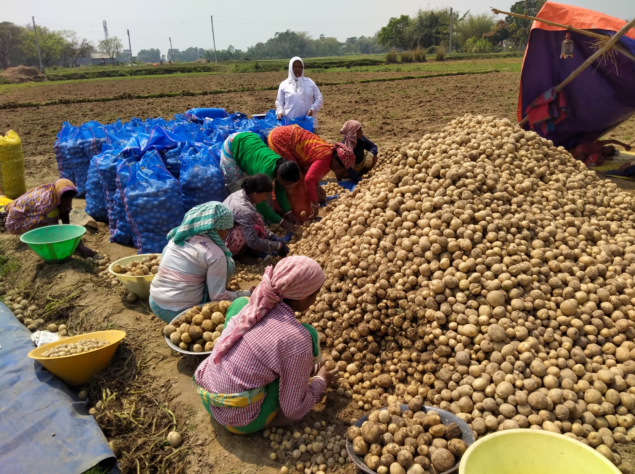

Integrated Natural Resource Management (INRM)

HEARTH Monitoring and Evaluation Toolkit:

*Private Sector Engagement*

APRIL 2022

Integrated Natural Resource Management (INRM)

Sound management of natural resources is central to long-term development and resilience. Faced with an urgent need to reduce environmental degradation while improving human well-being, solutions that effectively integrate investments in natural resource management with economic and social development are increasingly urgent. INRM promotes integrated programming across environment and non-environment sectors and across the Program Cycle. INRM supports USAID to amplify program impacts, strengthen gender equality and social inclusion, and identify best practices for integration.

For more information:   
https://land-links.org/project/integrated-natural-resource-management-inrm-activity/

|  |  |
| --- | --- |
| **Date of Publication:** | April 2022 |
| **Authors:** | Samantha Cheng, Mike Duthie, Daniel Evans, Aaron Ferguson, Andres Gomez, Scott Miller, Christina Seybolt, and Meredith Wiggins |
| **Front Cover photo:** | USAID partnered with PepsiCo to empower women farmers in West Bengal, India. Photo by USAID Land. |

This document was produced for review by the United States Agency for International Development under the Strengthening Tenure and Resource Rights II (STARR II) IDIQ contract number 7200AA20F00010.

The authors’ views expressed in this publication do not necessarily reflect the views of the United States Agency for International Development or the United States Government.

Contents

Acronyms iv

Overview 1

How To Use This Toolkit 1

Indicator Guidance 2

Outcomes and Indicators for Private Sector Engagement 3

Private Sector Engagement 4

Pathways To Change 4

Recommended Outcomes and Indicators 4

Performance Indicator Reference Sheets 6

# Acronyms

|  |  |
| --- | --- |
| DHS  HEARTH | Demographic and Health Surveys  Health, Ecosystems, and Agriculture for Resilient Thriving Societies |
| INRM | Integrated Natural Resource Management |
| IP | Implementing Partner |
| MERL | Monitoring, Evaluation, Research, and Learning |
| NGO | Non-Government Organization |
| PIRS | Performance Indicator Reference Sheet |
| PSE  STARR II | Private Sector Engagement  Strengthening Tenure and Resource Rights II |
| USAID | United States Agency for International Development |
| USD | United States Dollar |
| USG | United States Government |

# Overview

Together, Health, Ecosystems, and Agriculture for Resilient Thriving Societies (HEARTH) and INRM have created the HEARTH Monitoring and Evaluation Toolkit, a suite of indicators and guidance that will help United States Agency for International Development (USAID) Missions and implementing partners (IPs) monitor progress and aggregate common metrics to build the evidence base around the effectiveness of integrated strategic approaches. This document is an individual module from the toolkit, presented separately to facilitate use by individual HEARTH activities. Before using this module, we recommend first accessing the full toolkit and reviewing the list of sectors covered by each module, and determining which are most relevant for your activity:

[Access Full Toolkit on Biodiversity Links Here](https://biodiversitylinks.org/projects/current-global-projects/integrated-natural-resource-management-inrm/usaid-hearth-monitoring-and-evaluation-toolkit-2022-4-508.pdf/view).

## How To Use This Toolkit

This toolkit presents a **menu of options** for outcomes and recommended indicators across the HEARTH activities. Before using this toolkit, activities should have developed a robust theory of change – through first drafting their situation model and results chains during the co-design workshops, many of which have been completed already, and then validating and refining those results chains during start-up workshops.

Based on the activity theory of change, HEARTHs should develop their Activity Monitoring, Evaluation, Research, and Learning (MERL) Plan, which should draw directly from the toolkit. It is not expected that all outcomes or indicators will be relevant for all activities, but that activities should select those in line with their results chains and activity theory of change. Additionally, there might be activity-specific outcomes not included in this toolkit because they were not generally applicable across the HEARTH portfolio, and Missions and IPs should therefore include additional indicators in their MERL plans, as relevant.

When developing activity MERL plans, the indicators in this toolkit are intended to be used both to **standardize reporting for monitoring data, as well as a basis for evaluation data collection**. While monitoring trends in these indicators over time may be important for some activities, USAID anticipates that Missions and IPs will also identify important questions about the causal impact of their activities during the start-up activities, best answered using evaluation approaches. Which indicators will be part of monitoring systems, and which will be used to answer evaluation questions, will affect how the toolkit is operationalized. In addition, it is expected that MERL plans will likely include **qualitative data sources**, important to further explaining monitoring and evaluation results and exploring learning questions in more depth, in addition to the quantitative data collected using the approaches from the toolkit.

Diagram


Indicator Guidance

This document contains guidance for defining and collecting data for each of the recommended indicators for Missions and IPs, including Performance Indicator Reference Sheets throughout. All of the proposed PSE indicators should be collected from Operating Units and Implementing Partners records. For more information on the number of USG engagements jointly undertaken with the private sector and the number of private sector enterprises that engaged with the USG indicators, please see the USAID **Standard Agency Private Sector Engagement (PSE) Indicators and Harmonizing Indicator Tool**,[1] which includes templates for data collection.

## Outcomes and Indicators for Private Sector Engagement

***Table 1:*** *Overview of Outcomes and Recommended Indicators for the Private Sector Engagement Sector.*

| **Outcomes** | **HEARTH Portfolio Indicators** |
| --- | --- |
| Increased private sector engagement | * Number of USG engagements jointly undertaken with the private sector * Number of private sector enterprises that engaged with the USG * Investment leveraged from private sector engagements with the USG to support U.S. Foreign Assistance objectives (in United States Dollar (USD)) |

# 

# Private Sector Engagement

## Pathways To Change

Partnerships with the private sector are central to the HEARTH model to advance integrated investments in conservation, agriculture, health, governance, and other sectors. Measuring the number of USAID engagements jointly undertaken with the private sector and the number of private sector enterprises engaged with USAID to support U.S. foreign assistance objectives will allow the HEARTH portfolio to report on its success building these public-private partnerships. Measuring the amount of investment leveraged from the private sector, when combined with metrics on the number of joint engagements and number of enterprises engaged, will provide an indication of the depth of investments made across HEARTH.

## Recommended Outcomes and Indicators

| **Outcome** | **Description** | **Recommended Indicator** |
| --- | --- | --- |
| Increased private sector engagement | This indicator measures the breadth of USAID engagement with the private sector for the reporting year. An engagement is defined as a “strategic approach to planning and programming through which [the United States Government (USG)] consults, strategizes, aligns, collaborates, and implements with the private sector for greater scale, sustainability, and effectiveness of development or humanitarian outcome”. Engagements “affect the approach or programmatic strategy or objective in achieving the desired U.S. foreign assistance objective.” An engagement is purpose oriented and can be a convening of private sector actors or a series of interactions with the private sector actor(s). For more details, please see USAID’s Private Sector Engagement Policy and Standard Indicator Reference Sheet.[2] | **Indicator:** Number of USG engagements jointly undertaken with the private sector[3] |
|  | This indicator sums the total number of private sector enterprises worked with in the reporting year. A private sector enterprise is defined as “For-profit, commercial entities and their affiliated foundations; financial enterprises, investors and intermediaries; business associations and cooperatives”. Private Sector enterprises can vary in size and origin. For more details, please see USAID’s Private Sector Engagement Policy. | **Indicator:** Number of private sector enterprises that engaged with the USG[4] |
|  | This indicator measures the amount of investment in United States Dollar (USD) leveraged through USAID engagement with the private sector for the reporting year. Investment leveraged is defined as the total amount in USD that private sector enterprises have spent through USAID joint engagements. | **Indicator:** Investment leveraged from private sector engagements with the USG to support U.S. Foreign Assistance objectives (in USD) |

## Performance Indicator Reference Sheets

| **INDICATOR TITLE: Number of USG engagements jointly undertaken with the private sector to achieve a U.S. foreign assistance objective** | |
| --- | --- |
| DEFINITION:  This indicator measures the breadth of USAID engagement with the private sector for the reporting year. An engagement is defined as a “strategic approach to planning and programming through which [the USG] consults, strategizes, aligns, collaborates, and implements with the private sector for greater scale, sustainability, and effectiveness of development or humanitarian outcome” (see USAID Private Sector Engagement Policy).[5]  An engagement can be tangible/formal with a documented arrangement (e.g., financial assistance, materials, provision of goods and services) or informational/informal (e.g., convenings, facilitation, strategy development) exchange between a private sector actor and the USG or USG implementer. An engagement counts towards this indicator if the interactions between the USG and the private sector result in a documented exchange (e.g., memorandum of understanding, strategy, activity design documentation) that affects the approach or programmatic strategy or objective in achieving the desired U.S. foreign assistance objective.  An engagement can be one convening of private sector actors or a series of interactions with the private sector actor(s). An informational meeting with a business that does not yield documented changes to either the business or the USG’s strategic or programmatic approaches would not count. A Memorandum of Understanding that does not yield changes in the behavior of either the USG or the private sector actor in their approach to the MOU’s stated objective does not count as an engagement.  An engagement can have multiple documented purposes:   * Strategic Alignment, Project Design and Planning: engagements that advance development of complementary strategies and project design in line with U.S. foreign assistance objective(s) * Advocacy/Strengthening the Enabling Environment: engagements that address regulatory, legislative, and rule of law bottlenecks in a country’s business enabling environment * Harnessing Private Sector Expertise and Innovation: engagements that harnesses innovation, technology, research and development, industry expertise, and/or entrepreneurial skills to achieve development outcomes with or without USG financial commitments * Mobilizing Private Sector Financial Resources: engagements that leverage private-sector funding – including corporate social responsibility and philanthropy assets – or increase access to markets –such as through foreign direct investment or credit guarantees-- to address a U.S. foreign assistance objective with or without USG financial commitments * Technical Assistance to Local Private Sector Actors – engagements that provide capacity building services-- such as training or mentoring/coaching-- to local private sector actors. Engagements with local or international private sector actors that only provide capacity building support to the local private sector is not counted   Multiple USG engagements can occur within an implementing mechanism carrying out an activity. USG engagements can also occur outside any formal procurement process such as actions that aim to identify shared interests or jointly advocate for regulatory reforms and other enabling environment actions.  The private sector is defined as “For-profit, commercial entities and their affiliated foundations; financial institutions, investors and intermediaries; business associations and cooperatives; micro, small, medium and large enterprises that operate in the formal and informal sectors; American, local, regional, and multinational businesses; and For-profit approaches that generate sustainable income (e.g., a venture fund run by a non-governmental organization (NGO) or a social enterprise)” (See USAID’s Private Sector Engagement Policy)  “Jointly undertaken” is defined as an engagement between the USG, or a USG implementer, and the private sector that results in a coordinated action that can be implemented jointly, or separately in parallel.  U.S. foreign assistance objective refers to strategic, development, and humanitarian assistance objectives as identified in the Department of State-USAID Joint Strategic Plan and USAID Country Development and Cooperation Strategies.  Under the “purpose of joint engagement” and “U.S. foreign assistance objective addressed” disaggregates, count all purposes and objectives that apply to the engagement. These disaggregates do not need to aggregate to the total result reported under the parent indicator.  Report the engagement only once under the “market-based engagement” disaggregate. A market-based approach is defined as the use of business models and leveraging of market forces to solve development and humanitarian challenges without beyond the life of the engagement and without USG assistance. Proof of concept is not needed for an engagement to count toward this disaggregate. To be counted, documentation must exist that either market forces were addressed, or a business model developed as part of the engagement development process with private enterprise(s). This documentation is typically found in implementation plans, strategy design, or Monitoring, Evaluation, Research, and Learning (MERL) frameworks.  Corporate or Private Philanthropies and Foundation engagement with the USG that use business models and leveraging of market forces in the design and implementation of the engagement count as a market-based engagement. A market-based approach can engage low-income people as customers and supply them with products and services they can afford; or, as business associates (suppliers, agents, or distributors), to provide them with improved incomes. | | |
| UNIT:  Number (USD) | DISAGGREGATE BY:  **Purpose of Joint Engagement:** Strategic Alignment/Planning; Advocacy/Strengthening the Enabling Environment; Harnessing Private Sector Expertise & Innovation; Mobilizing private sector financial resources; Provided Technical Assistance to the Local Private Sector; Other  **U.S. Foreign Assistance Objective:** Peace and Security; Democracy and Governance; Health; Education; Economic Growth; Climate Change; Environment; Food Security, Nutrition Resilience Water, Hygiene, and Sanitation; Other  **Type of Engagement:** Market-Based; Non-Market Based | |
| TYPE:  Output | DIRECTION OF CHANGE:  Higher is better | |
| FREQUENCY:  Annual | DATA SOURCE:  Operating Units and Implementing Partners records | |
| REPORTING NOTES | | |
| This indicator is a snapshot indicator and cannot be summed across reporting years to calculate a total for the life of an activity. Engagements that continue beyond the reporting year should be counted for each reporting year that it is active. | | |

| **INDICATOR TITLE: Number of private sector enterprises that engaged with the USG to support U.S. Foreign Assistance objectives** | |
| --- | --- |
| DEFINITION:  This indicator sums the total number of private sector enterprises worked with in the reporting year. A private sector enterprise is defined as “For-profit, commercial entities and their affiliated foundations; financial enterprises, investors and intermediaries; business associations and cooperatives” (See USAID’s Private Sector Engagement Policy).[6] Private Sector enterprises can vary in size and origin.  An engagement is defined as a tangible/formal with documented arrangement (e.g., financial assistance, materials, provision of goods and services) or informational/informal (e.g., convenings, facilitation, strategy development) exchange between a private sector enterprise and the USG or USG implementer. An engagement counts towards this indicator if the interactions between the USG and the private sector result in a documented exchange (tangible or informational) that affects the approach or programmatic strategy or objective in achieving the desired U.S. foreign assistance objective.  An engagement can be one convening of private sector actors or a series of interactions with the private sector actor(s). An informational meeting with a business that does not yield documented changes to either the business or the USG’s strategic or programmatic approaches would not count. A Memorandum of Understanding that does not yield changes in the behavior of either the USG or the private sector actor in their approach to the MOU’s stated objective does not count as an engagement.  U.S. foreign assistance objective refers to strategic, development, and humanitarian assistance objectives as identified in the Department of State-USAID Joint Strategic Plan and USAID Country Development and Cooperation Strategies.  There are four disaggregate types: U.S. Foreign Assistance Objective(s) Addressed, type of private sector enterprise, origin of private sector enterprise, and the size of the private sector enterprise. Count the private sector enterprise only once under the “Type of Private Sector enterprise,” “Origin of Private Sector enterprise,” and “Size of Private Sector enterprise.” You can select all the disaggregate types that apply to the private sector enterprise under the “U.S. Foreign Assistance Objective(s) Addressed.” | | |
| UNIT:  Number (USD) | DISAGGREGATE BY:  **U.S. Foreign Assistance Objective:** Peace and Security; Democracy and Governance; Health; Education; Economic Growth; Climate Change; Environment; Food Security, Nutrition Resilience Water, Hygiene, and Sanitation; Other  **Type of Private Sector enterprise:** For-profit commercial entities (excluding financial enterprises and social enterprises); Private financial enterprises (excluding social enterprises); Private social enterprises; Corporate foundations and corporate philanthropic entities; Private grant-making foundations Business, Trade and Industry Associations (including Chambers of Commerce); Private Cooperatives; Other  **Origin of Private Sector enterprise:** US-Based; Host Country-Based; Third Country-Based | |
| TYPE:  Output | DIRECTION OF CHANGE:  Higher is better | |
| FREQUENCY:  Annual | DATA SOURCE:  Operating Units and Implementing Partners records | |
| REPORTING NOTES | | |
| This indicator is a snapshot indicator and cannot be summed across reporting years to calculate a total for the life of an activity. Engagements that continue beyond the reporting year should be counted for each reporting year that it is active.  **PPR REPORTING NOTE**: list all private enterprise names in the indicator narrative when reporting for the PPR. USAID will be responsible for analyzing data and cleaning any double counting as data are aggregated to reflect Agency-level results for the fiscal year. | | |

| **INDICATOR TITLE: Investment leveraged from private sector engagements with the USG to support U.S. Foreign Assistance objectives (in USD)** | |
| --- | --- |
| DEFINITION:  This indicator measures the amount of investment in USD leveraged through USAID engagement with the private sector for the reporting year. **Investment leveraged** is defined as the total amount in USD that private sector partners bring to the HEARTH activities (the portion not contributed by USAID) and should include both cash and in-kind resources.  A **private sector enterprise** is defined as “For-profit, commercial entities and their affiliated foundations; financial enterprises, investors and intermediaries; business associations and cooperatives” (See USAID’s Private Sector Engagement Policy).[7] Private Sector enterprises can vary in size and origin.  An **engagement** is defined as a tangible/formal with documented arrangement (e.g., financial assistance, materials, provision of goods and services) or informational/informal (e.g., convenings, facilitation, strategy development) exchange between a private sector enterprise and the USG or USG implementer. An engagement counts towards this indicator if the interactions between the USG and the private sector result in a documented exchange (tangible or informational) that affects the approach or programmatic strategy or objective in achieving the desired U.S. foreign assistance objective.  An engagement can be one convening of private sector enterprises or a series of interactions with the private sector enterprise(s). An informational meeting with a business that does not yield documented changes to either the business or the USG’s strategic or programmatic approaches would not count. A Memorandum of Understanding that does not yield changes in the behavior of either the USG or the private sector enterprise in their approach to the MOU’s stated objective does not count as an engagement.  **U.S. foreign assistance objective** refers to strategic, development, and humanitarian assistance objectives as identified in the Department of State-USAID Joint Strategic Plan and USAID Country Development and Cooperation Strategies. | | |
| UNIT:  Number (USD) | DISAGGREGATE BY:  **U.S. Foreign Assistance Objective:** Peace and Security; Democracy and Governance; Health; Education; Economic Growth; Climate Change; Environment; Food Security, Nutrition; Resilience; Water, Hygiene, and Sanitation; Other  **Type of Private Sector enterprise:** For-profit commercial entities (excluding financial enterprises and social enterprises); Private financial enterprises (excluding social enterprises); Private social enterprises; Corporate foundations and corporate philanthropic entities; Private grant-making foundations; Business, Trade, and Industry Associations (including Chambers of Commerce); Private Cooperatives; Other  **Origin of Private Sector enterprise:** US-Based; Host Country-Based; Third Country-Based | |
| TYPE:  Output | DIRECTION OF CHANGE:  Higher is better | |
| FREQUENCY:  Annual | DATA SOURCE:  Operating Units and Implementing Partners records | |
| REPORTING NOTES | | |
| Count the private sector enterprise only once under the “Type of Private Sector enterprise,” and “Origin of Private Sector enterprise.” You can select all the disaggregate types that apply to the private sector enterprise under the “U.S. Foreign Assistance Objective(s) Addressed.”  Please list all private enterprise names in the indicator narrative when reporting. USAID will be responsible for analyzing data and cleaning any double counting as data are aggregated to reflect Agency-level results for the fiscal year. | | |

1. Lab, Learning. “PSE MEL: Standard Agency PSE Indicators and Harmonizing Indicator Tool.” USAID Learning Lab. United States Agency for International Development, September 24, 2021. https://usaidlearninglab.org/library/pse-mel-standard-agency-pse-indicators-and-harmonizing-indicator-tool.
2. “Private-Sector Engagement Policy.” United States Agency for International Development, 2018. https://www.usaid.gov/sites/default/files/documents/1865/usaid_psepolicy_final.pdf.
3. Fact Sheet Collaborating, Learning and Adapting at USAID. Number of Engagements, n.d. https://prod.usaidlearninglab.org/sites/default/files/resource/files/110117_usaid_fact_sheets_final.pdf.
4. Fact Sheet Collaborating, Learning and Adapting at USAID. Number of Private Sector Enterprises, n.d. https://usaidlearninglab.org/sites/default/files/resource/files/pse_2_-_number_of_ps_enterprises.pdf.
5. “Private-Sector Engagement Policy.” United States Agency for International Development, 2018. https://www.usaid.gov/sites/default/files/documents/1865/usaid_psepolicy_final.pdf.
6. “Private-Sector Engagement Policy.” United States Agency for International Development, 2018. https://www.usaid.gov/sites/default/files/documents/1865/usaid_psepolicy_final.pdf.
7. ibid